Upload/ delete attachment to the paper bid in Georgia Procurement Registry(GPR)
Step # | Action
1 | Login to GPR. Link: https://ssl.doas.state.ga.us/PRSapp/PR_login.jsp
2 | To upload any attachment/s to the paper bid Main Menu> Bid Processing> Add a document to a bid >(Select FY Year) Click on ‘Process’ > Select Bid> Click on ‘Browse’ to upload the attachment> Name the attachment> Click on ‘process’> Click on ’Return To Menu’ to go back.  - This will send email alert to all associated suppliers.  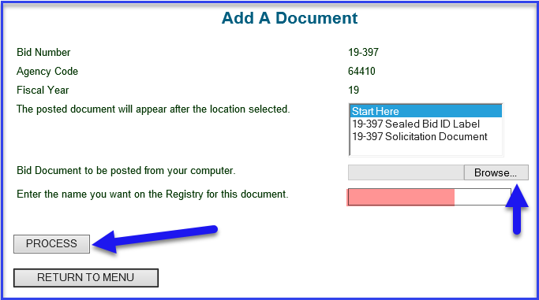
3 | To delete any attachment/s to the paper bid Main Menu> Bid Processing> Delete a Document to a bid >(Select FY Year) Click on ‘Process’ > Select Bid> Select the attachment that needs to be deleted > Click on ‘process’> Click on ’Return To Menu’ to go back.  